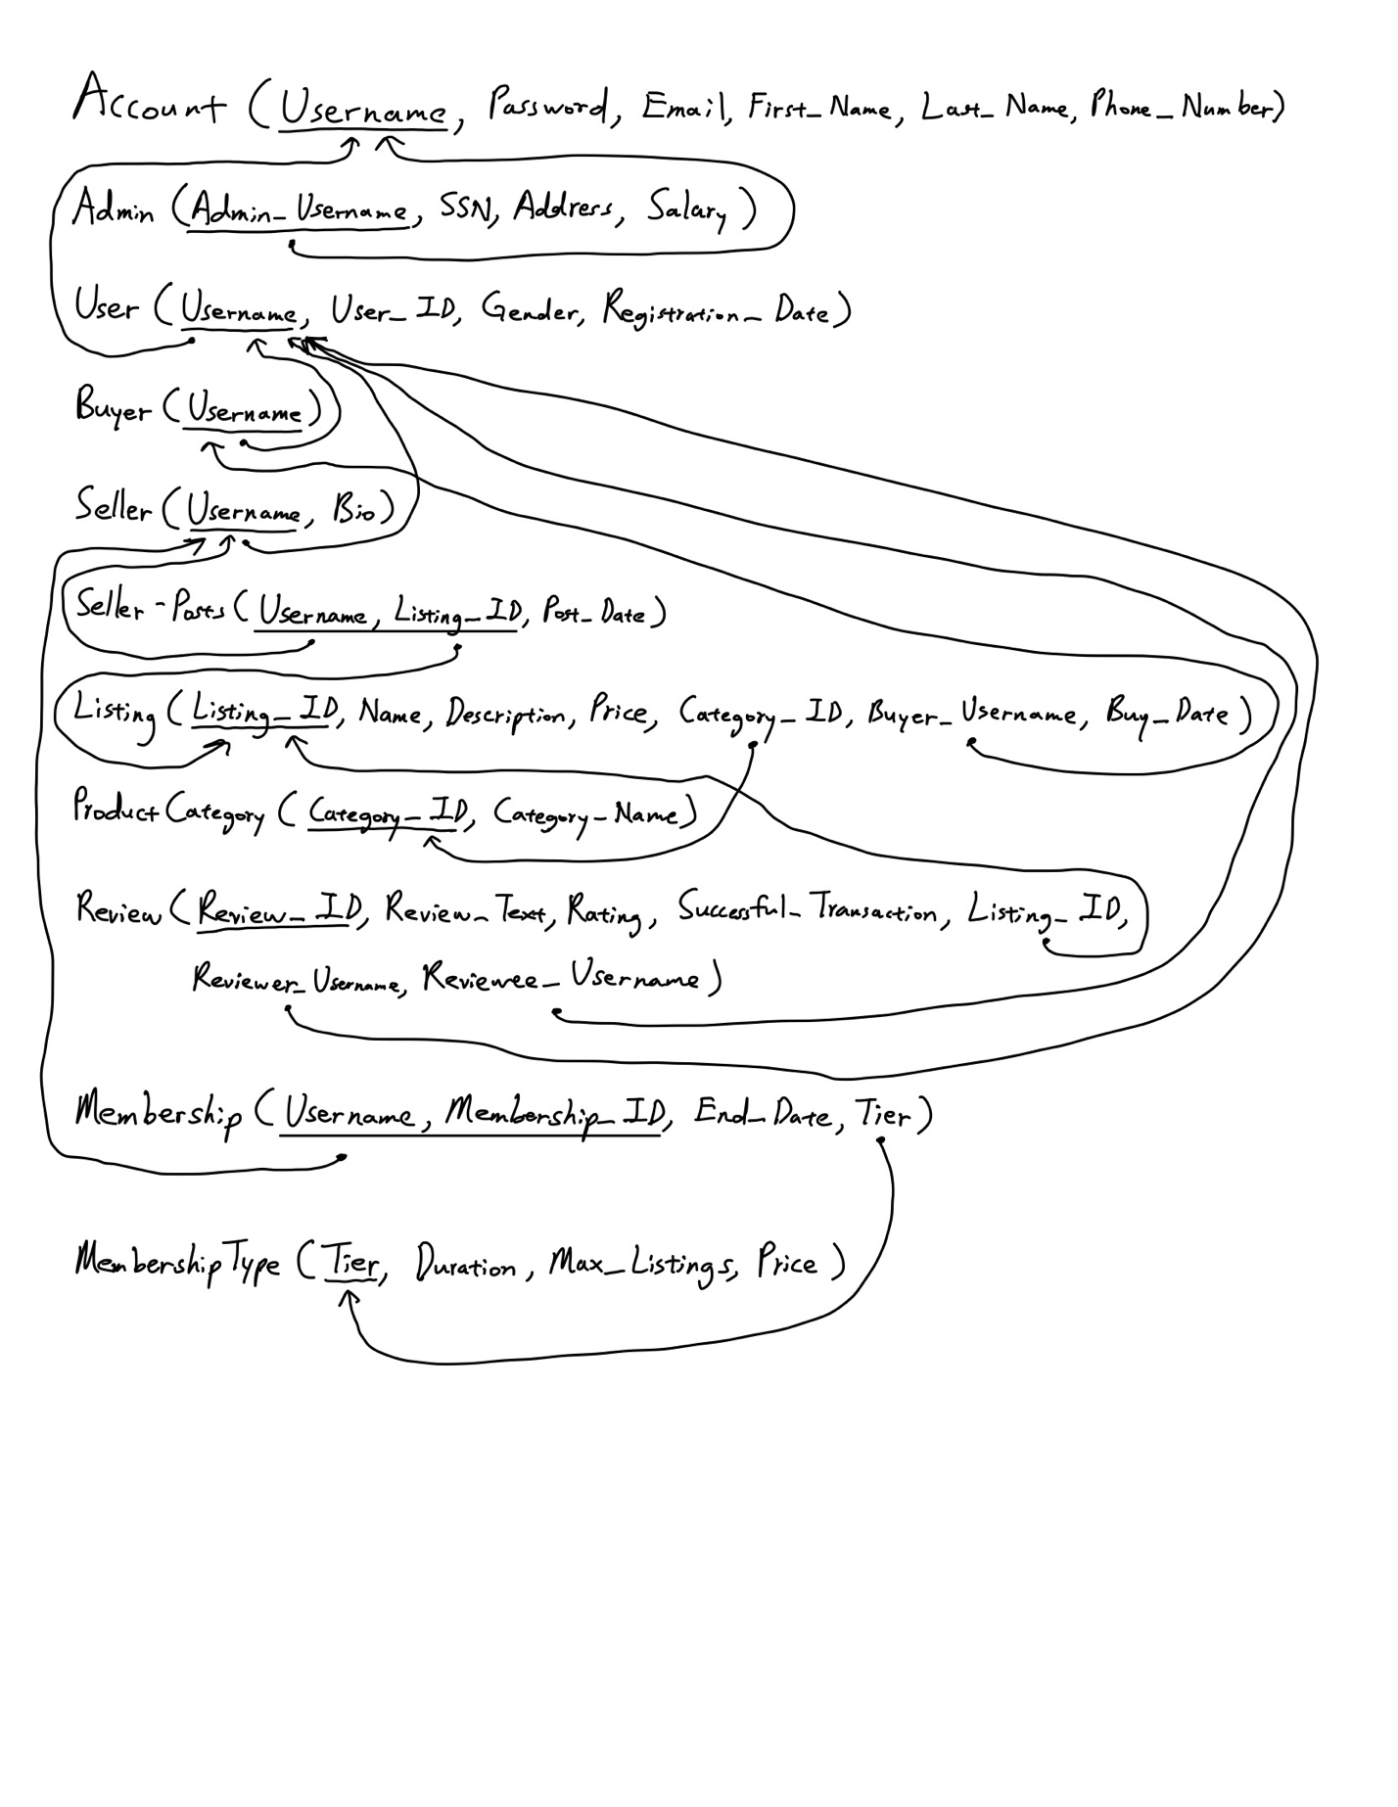

**Candidate Keys:**

Account:

* Username
* Email
* Phone_Number

Admin:

* Username
* SSN

User:

* Username
* User_ID

Buyer:

* Username

Seller:

* Username

Seller-Posts:

* Listing_ID

Listing:

* Listing_ID

Listing-Photos:

* Listing_ID, Photos

ProductCategory:

* Category_ID

Review:

* Review_ID
* Listing_ID, Reviewer_Username, Reviewee_Username

Membership:

* Membership_ID
* Username, End_Date

MembershipType:

* Tier

**Functional Dependencies:**

Account:

* Username -> Password, Email, First_Name, Last_Name, Phone_Number
* Email -> Username, Password, First_Name, Last_Name, Phone_Number

Admin:

* Username -> SSN, Address, Salary
* SSN -> Username, Address, Salary

User:

* Username -> User_ID, Gender, Registration_Date
* User_ID -> Username, Gender, Registration_Date

Buyer:

* Username -> Username

Seller:

* Username -> Bio

Seller-Posts:

* Username, Listing_ID -> Post_Date
* Listing_ID -> Username, Post_Date

Listing:

* Listing_ID -> Name, Description, Price, Category_ID, Buyer_Username, Buy_Date

Listing-Photos:

* Listing_ID, Photos -> Listing_ID, Photos

ProductCategory:

* Category_ID -> Category_Name

Review:

* Review_ID -> Review_Text, Rating, Successful_Transaction, Listing_ID, Reviewer_Username, Reviewee_Username
* Listing_ID, Reviewer_Username, Reviewee_Username -> Review_ID, Review_Text, Rating, Successful_Transaction

Membership:

* Membership_ID -> Username, End_Date, Tier
* Username, End_Date -> Membership_ID, Tier

MembershipType:

* Tier -> Duration, Max_Listings, Price

Team 7